Experiment no:1

Configuration of Network Devices using Packet Tracer (Hub, Switch, Ethernet, Broadcast)

### 

### AIM:

To establish a Local Area Network (LAN) using Cisco Packet Tracer.

### 

### REQUIREMENTS:

1. **End device** - They are the devices through which we can pass message from one device to another and they are interconnected.
2. **Switch/Hub** - Interface Between two devices.
3. **Cable** - Used to connect two devices.

Procedure:

**1)** Click on end devices, select generic Pc’s drag and drop it on the window. Click on SWITCH drag and drop it on the window.

**2)** Select the straight through cable and connect all end device to switch. Assign

the IP address for all end devices. (Double click the end device Select →

desktop → IP configuration static)

**3)** Now set the IP address to Host A (192.168.1.1) in static mode. Similarly set

IP address for Host B (192.168.1.2) and Host C (192.168.1.3)

**4)** To view the IP address, give ipconfig command in command prompt. Using ping command, we can establish communication between two host devices.

**5)** Now display the packet transmission in simulation mode.

Hub:

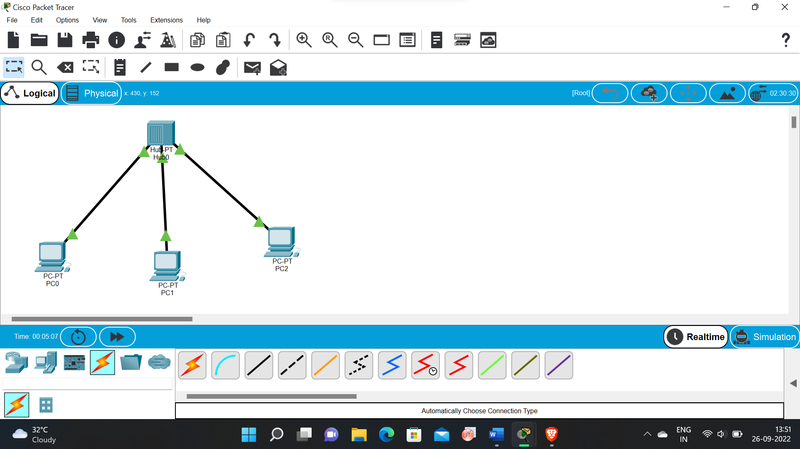

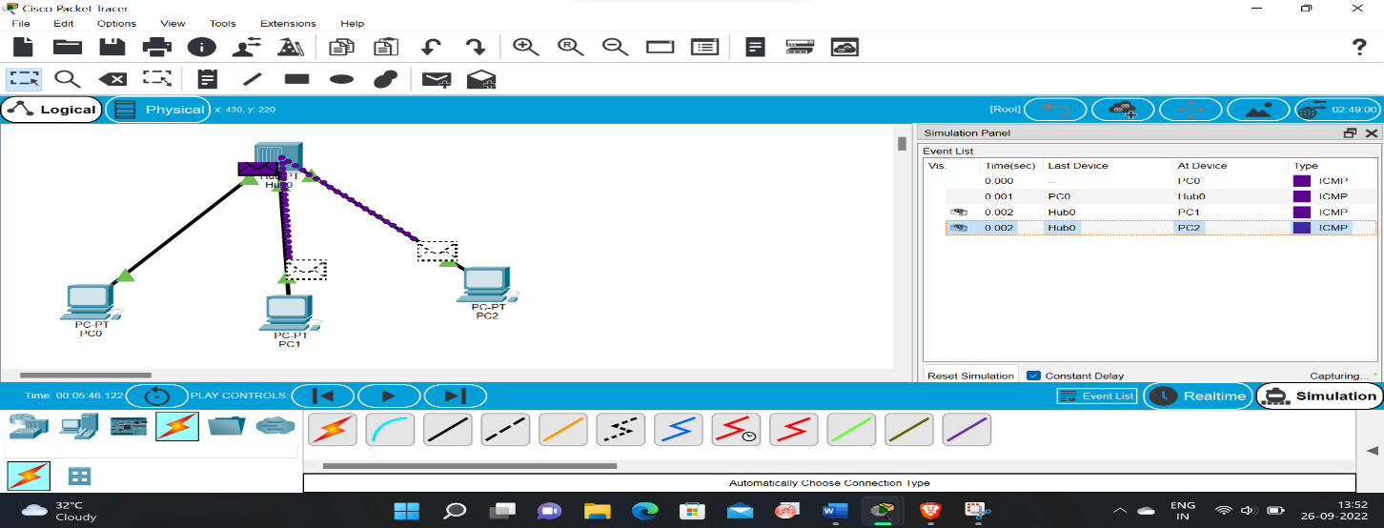

Switch:

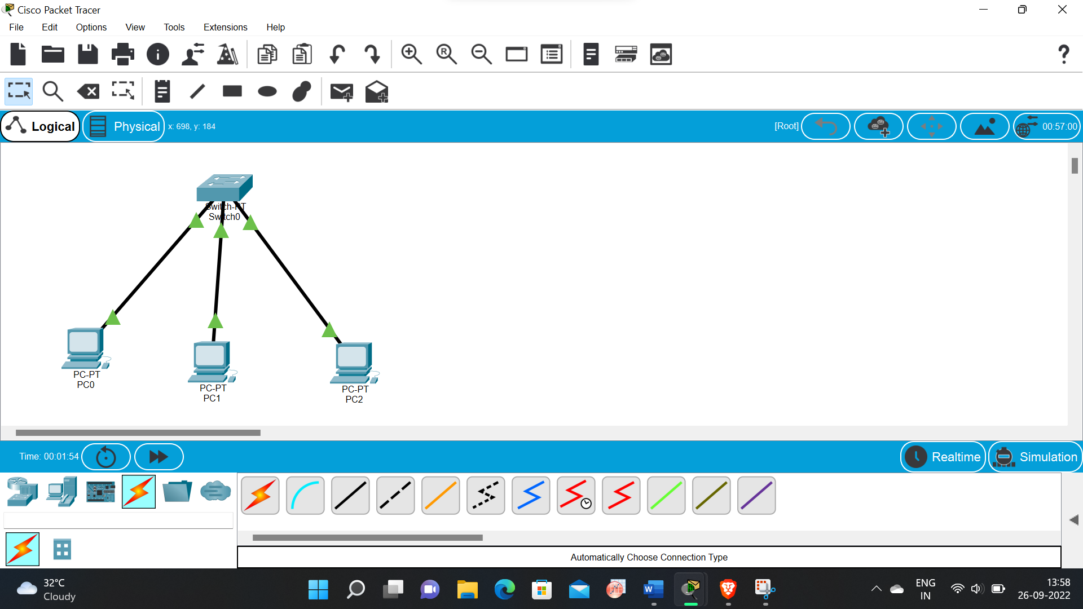

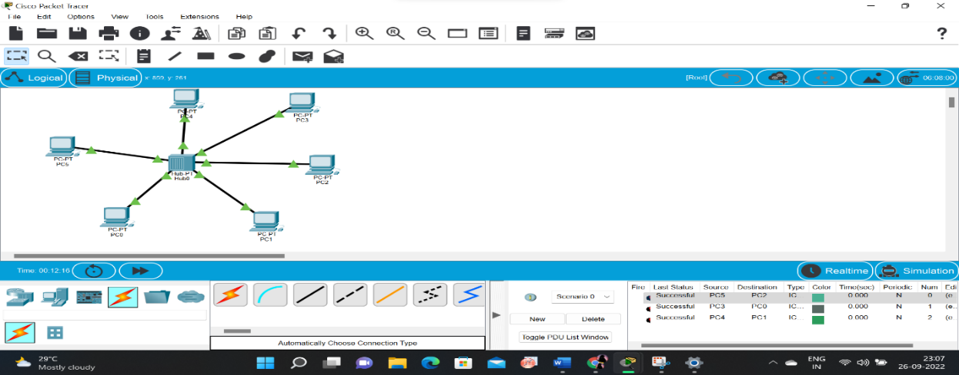

Ethernet:

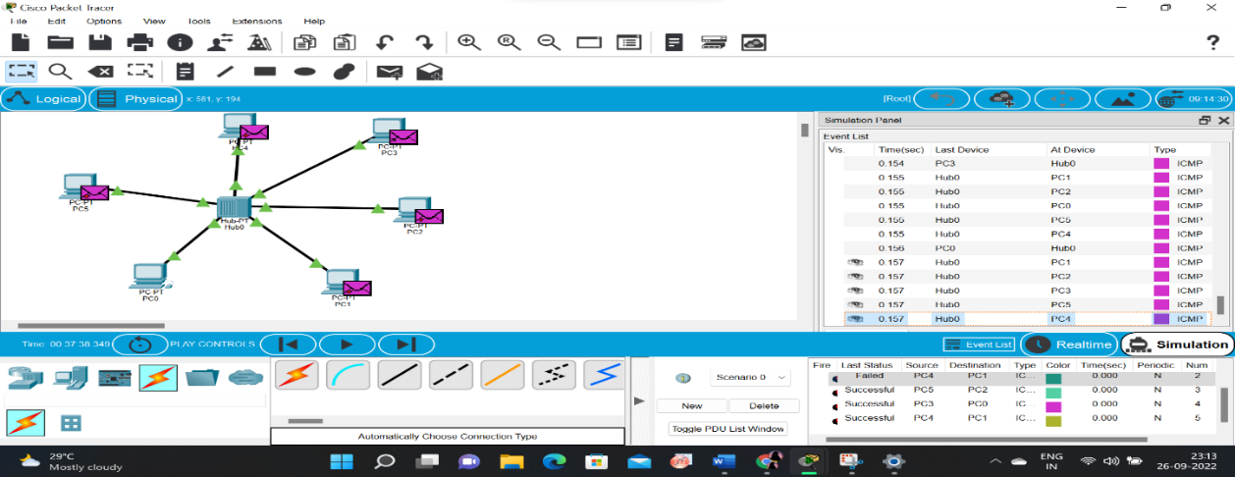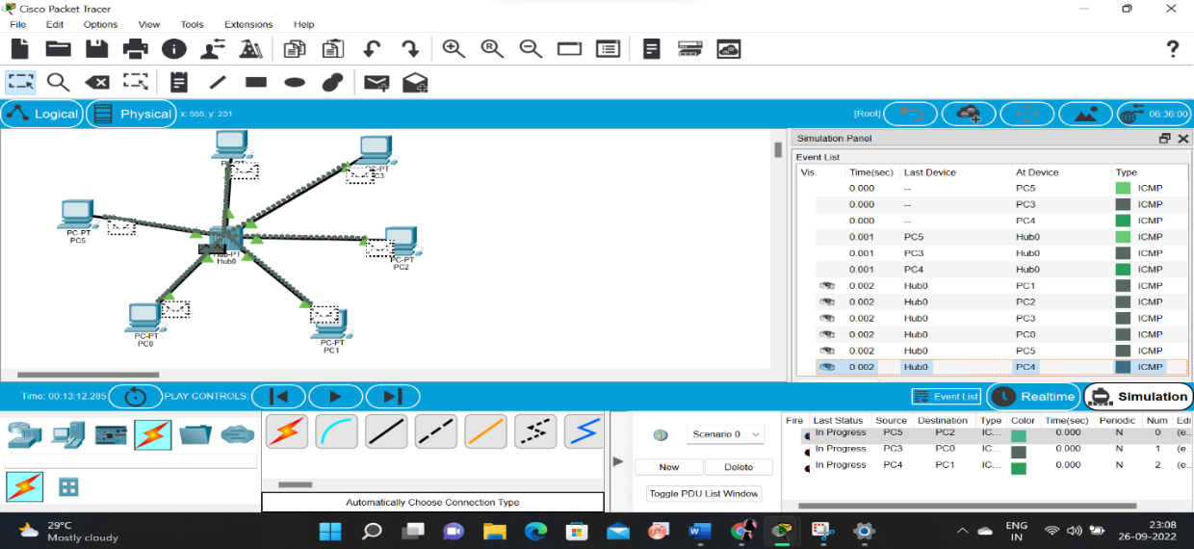

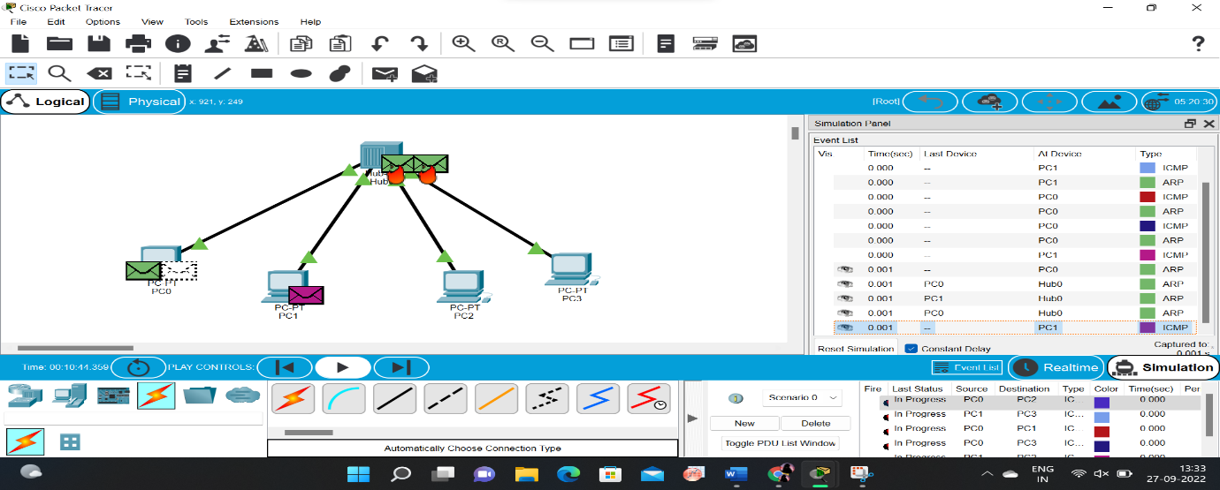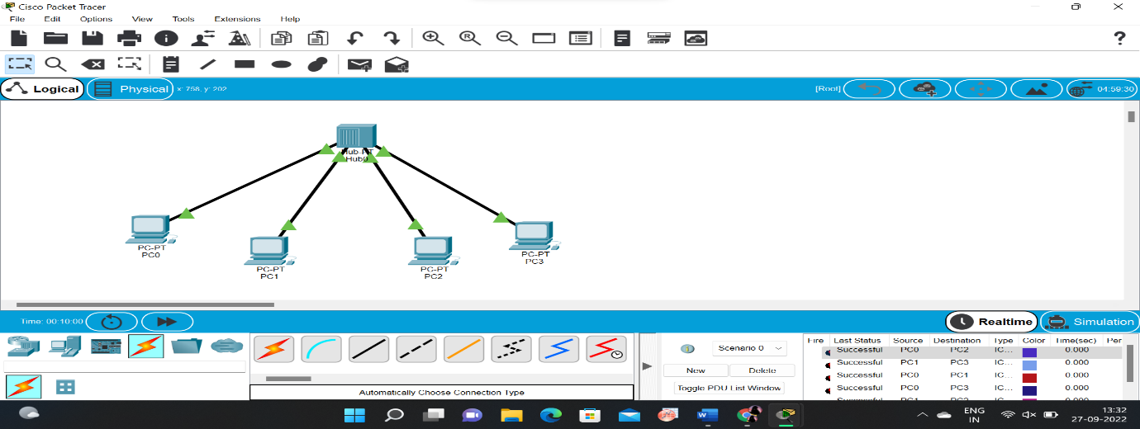broadcast:

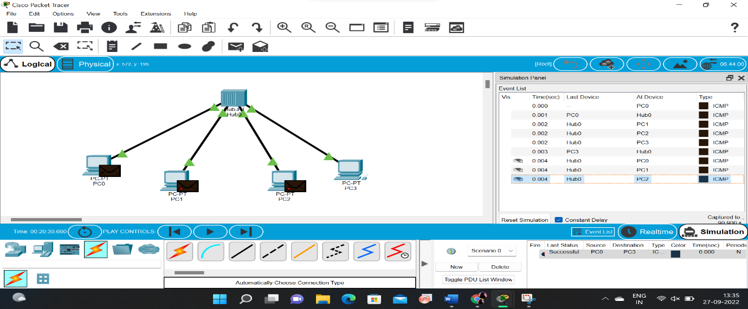

Result:

Configuration of Network Devices using Packet Tracer Hub, Switch, Ethernet, Broadcast is verified successfully.